**Enhanced shielding as an exit strategy from COVID-19 lockdown**

Mark Woolhouse, Alex Morgan, Paul Bessell & Bram van Bunnik

University of Edinburgh (10/04/20)

Recommendation

‘Enhanced shielding’ should be included among policy options for exiting COVID-19 lockdown.

Rationale

We already identify vulnerable persons and issue specific advice for them to ‘shield’ from possible COVID-19 infection. This covers both households and institutions containing vulnerable populations, hospitals and care homes in particular.

Policy is to i) save lives; ii) protect NHS physical capacity (especially ICUs) and iii) protect NHS staff (to maintain health services). Enhanced shielding could help meet all these goals.

Proposition: If COVID-19 was circulating *only* in the non-vulnerable population then a much smaller proportion of cases would present with severe disease and require hospitalisation/ critical care. The case fatality rate would be far lower.

Therefore, if we could reduce the incidence of infection in the vulnerable group the epidemic could be manageable. The shielding already advised is intended to reduce the incidence; to do more we need ‘enhanced shielding’.

Beyond existing shielding, the key additional element of enhanced shielding is very intensive screening of all individuals in contact with vulnerable persons. I.e. members of the same household, carers, community health workers, care home staff, hospital staff etc. We label these ‘vulnerable population contacts’ (VPCs).

The protocol for intensive screening of VPCs would need to be worked out in detail. A starting suggestion would be daily checks for symptoms, daily PCR tests (would have to be very rapid, i.e. <24 hours), regular serological testing and (perhaps) monitoring of frequent contacts (e.g. household members) of VPCs. [NB. daily PCR tests are specifically to detect pre-symptomatic infection].

Other protective measures (hygiene, self-isolation of cases, quarantine of households with cases etc.) would still be required.

Illustration

We use a very simple model (Appendix 1) to explore the possible impact of enhanced shielding.

The model generates two epidemic curves: 1) the vulnerable population; 2) the (larger) non-vulnerable population. We focus on levels of infection in the vulnerable population (which will lead over time to hospitalisations, ICU admissions and the great majority of deaths).

The outputs show that enhanced shielding can (in principle) keep the epidemic at manageable levels (i.e. no higher than the current first wave) for a prolonged period.

We conclude that enhanced shielding should be added to the policy options under consideration, most likely for use as integrated package of interventions.

Caveats

This is a very simple model. The analysis should be repeated with more detailed models.

The actual impact of enhanced shielding will depend crucially on contact patterns (with and without the intervention) between vulnerable and non-vulnerable populations and within the vulnerable population (same household, same care home, same geriatric ward etc.). This will need to be explored carefully.

The actual impact of enhanced shielding will depend crucially on the level of reductions in transmission rates achieved, especially from non-vulnerable to vulnerable populations. What is achievable in practice will need to be assessed carefully.

The long-term impact of enhanced shielding depends on the extent to which herd immunity builds up in the non-vulnerable population. Here we use an SIRS framework. Under an optimistic SIR (where there is a build-up of herd immunity) or pessimistic SIS assumption (where there is no herd immunity at all), the benefits to the non-vulnerable population remain, but the shielding of the vulnerable population must be maintained for (much) longer. In other words, the greater the extent to which herd immunity builds up in the non-vulnerable population the greater likelihood that shielding can be reduced, and reduced sooner.

Here, we have not considered enhanced shielding in isolation. Our baseline scenario assumes substantial reductions in *R*0 (to 1.7) achieved through measures in place before the current lockdown. In this model that reduction is sustained.

APPENDIX: Model outputs and model details.

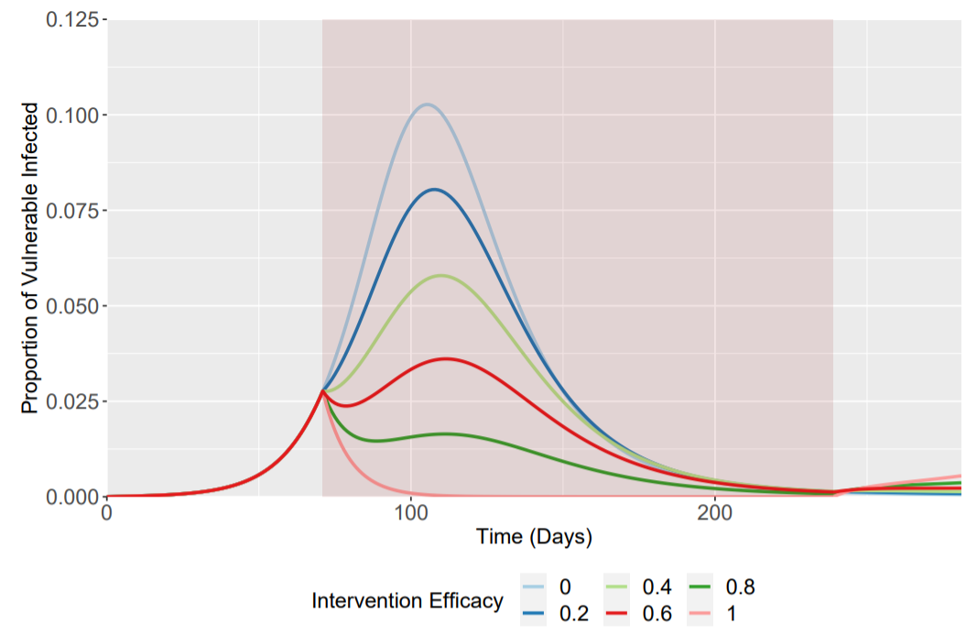

Figure 1. Epidemic curves for the vulnerable population only. Enhanced shielding for 24 weeks. Note that for 80% or 100% efficacy the first peak is the highest. The strategy does not work for 60%, 40%, 20% or 0% efficacy. Cumulative *Is* ranges from 0.76 (0% efficacy) to 0.09 (100%). Red shading denotes the duration of the intervention.

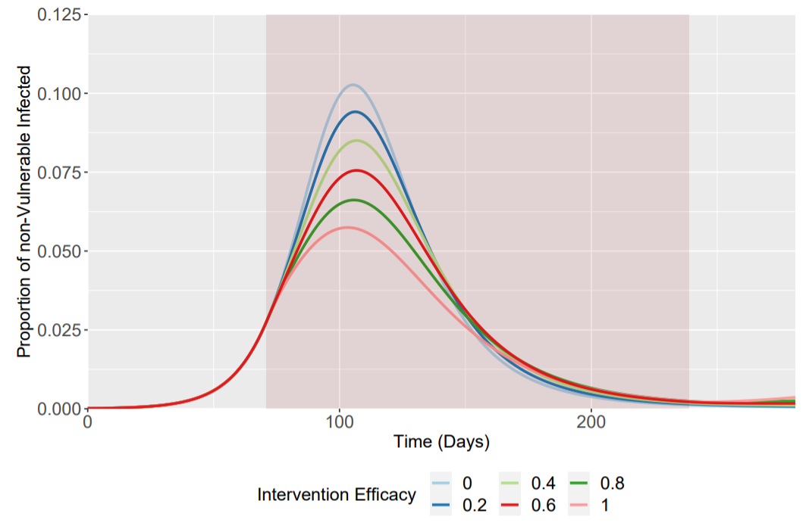

Figure 2. Epidemic curves for the non-vulnerable population only. Red shading denotes the duration of the intervention.

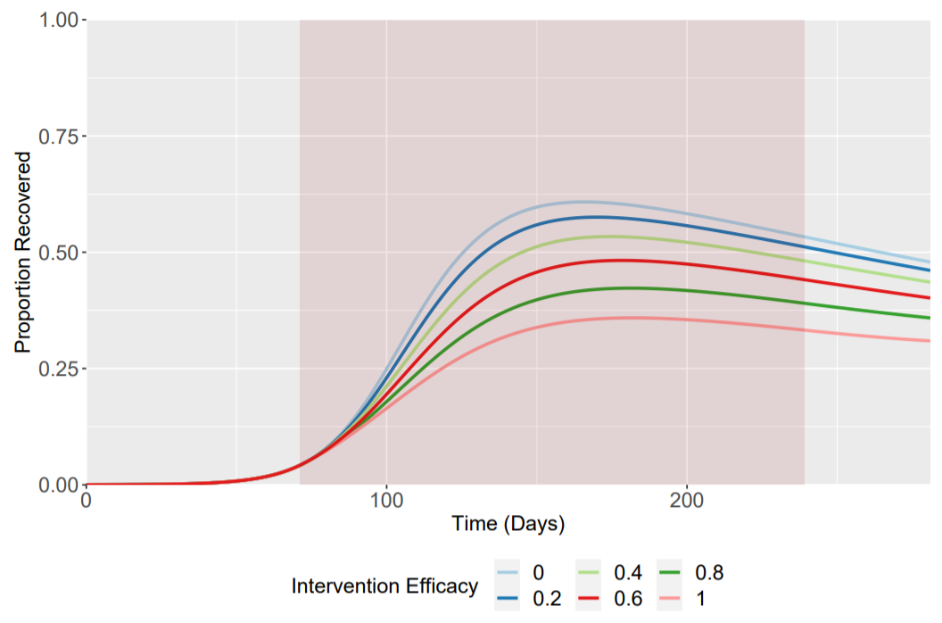

Figure 3. Epidemic curves for the recovered population (assuming SIRS).Depicted here is the total proportion recovered (i.e. Rv + Rnv). Red shading denotes the duration of the intervention.

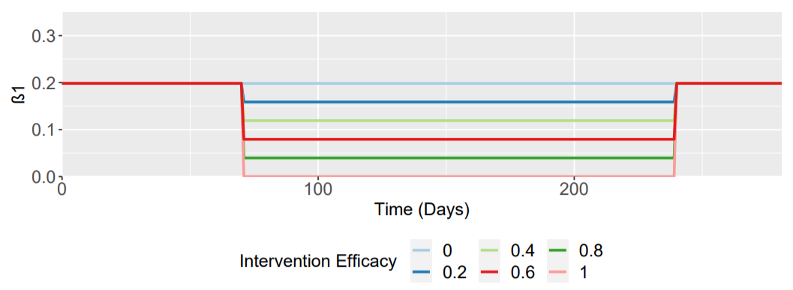

Figure 4. Assumed changes in transmission rates from non-vulnerable to vulnerable and within vulnerable population.

Model structure

Risk stratified SIRS model with two I compartments: vulnerable (*v*); non-vulnerable (*nv*).

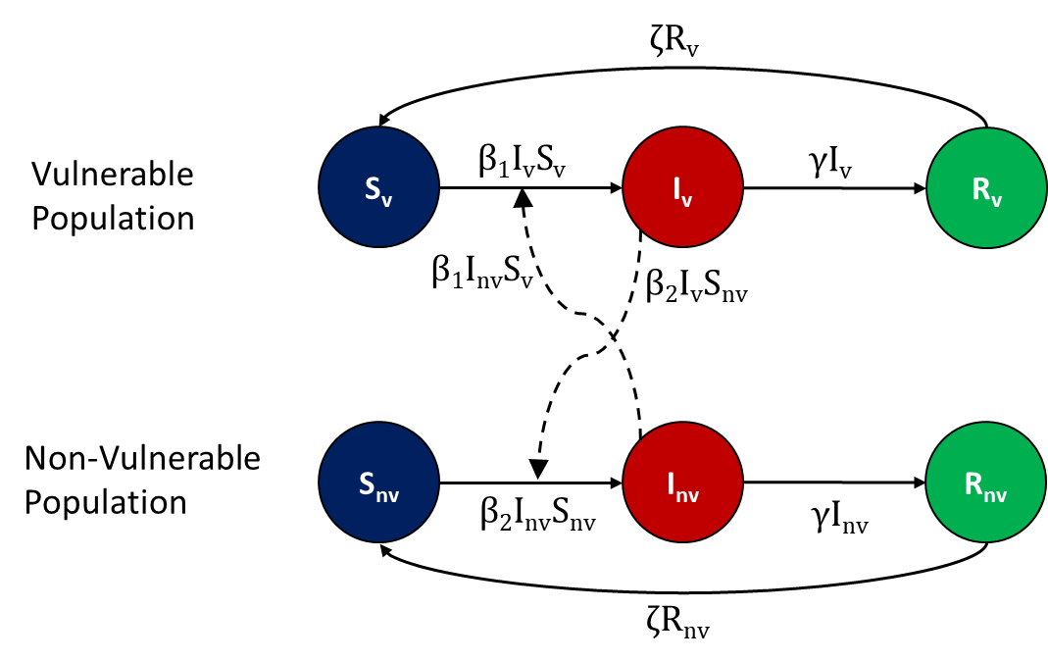

Baseline *R*0 = 1.7; Doubling time = 3.3; γ = 0.117, ζ = 1/365

β1 (baseline) = 0.198; β1c (intervention)= 0.8*β1, 0.6*β1, 0.4*β1, 0.2*β1, 0

β2 (throughout) = 0.198

Intervention point, *I*(*t*) = 0.028

Fraction vulnerable, *fv* = 0.20

Intervention length = 24 weeks

Implementation

$$\frac{dS_{v}}{dt}=-β_{1}I_{v}S_{v}-β_{1}I_{nv}S_{v}+ζR_{v}$$

$$\frac{dS_{nv}}{dt}=-β_{2}I_{nv}S_{nv}-β_{2}I_{v}S_{nv}+ζR_{nv}$$

$$\frac{dI_{v}}{dt}=β_{1}I_{v}S_{v}+β_{1}I_{nv}S_{v}-γI_{v}$$

$$\frac{dI_{nv}}{dt}=β_{2}I_{nv}S_{nv}+β_{2}I_{v}S_{nv}-γI_{nv}$$

$$\frac{dR_{v}}{dt}=γI_{v}-ζR_{v}$$

$$\frac{dR_{nv}}{dt}=γI_{nv} -ζR_{nv}$$

Model implemented in R and C++ independently.

Code available at <https://github.com/bvbunnik/COVID-19>

Sensitivity analyses

i) Higher baseline *R*0 = 2.8 (cf. 1.7).

Requires higher shielding efficacy (close to 100%) to achieve similar outcome (as peak *Inv* value).

ii) Different intervention points (equivalent to ±25 days start time)

Timing is important. For very effective interventions (>=80%) if the intervention point is 25 days earlier or later then the cumulative *Iv* is higher. However, peak *Iv* is lower for an earlier intervention point. [In practice, the position of the intervention point on the epidemic curve is uncertain].

iii) SIS or SIR not SIRS

This makes a very substantial difference. In the SIS case there is no herd immunity and, in the simplest scenario, enhanced shielding must be maintained indefinitely.

iv). Changes to the fraction vulnerable, *fv*

In the SIR scenarios the lower *fv* the more effective the intervention. However, for SIRS scenarios the post-intervention dynamics are much more complex and might be very difficult to predict in practice.